**Automation Testing by using Appium**

Appium is an open source test automation framework for use with native, hybrid and mobile web apps. It drives iOS, Android, and Windows apps using the WebDriver protocol.

It works on JSON Wire Protocol and it needs no recompilation after making small changes. It supports automation tests both on physical devices and as well as emulators.

Tolls required to run for Automation tests:

1. Android Studio.

2. Emulator (Preferably with Android Studio)

3. IDE to write Test Scripts (Intellij Community version)

4. Appium (Latest Version)

Following libraries are installed to run the scripts:

1. byte-buddy – 1.8.15.jar

2. commons-exec – 1.3.jar

3. commons-lang3 – 3.9.jar

4. commons -lang3 – 3.9-sources.jar

5. commons -lang3 –3.9-test-sources.jar

5. commons -lang3 -3.9-tests.jar

6. guava-25.0-jre.jar

7. java-client-7.3.0.jar

8. okhttp-3.11.0.jar

9. okio-1.14.0.jar

10 selenium-server-standalone-3.141.59.jar

The Test cases are written on intellij IDE where, we need to add necessary libraries related to the code scripts we are writing for. Here, we use JAVA to write test scripts to run the applications.

Emulator actually represents the mobile device on a computer screen where we can perform the click and swipe actions by using mouse or keypad on the computer.

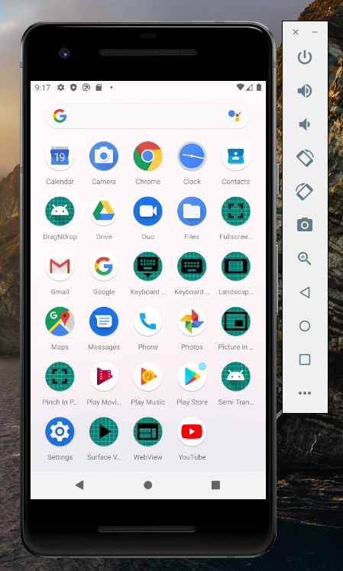

The IDE of Intellij contains the arena to write code and it looks almost similar to Android Studio

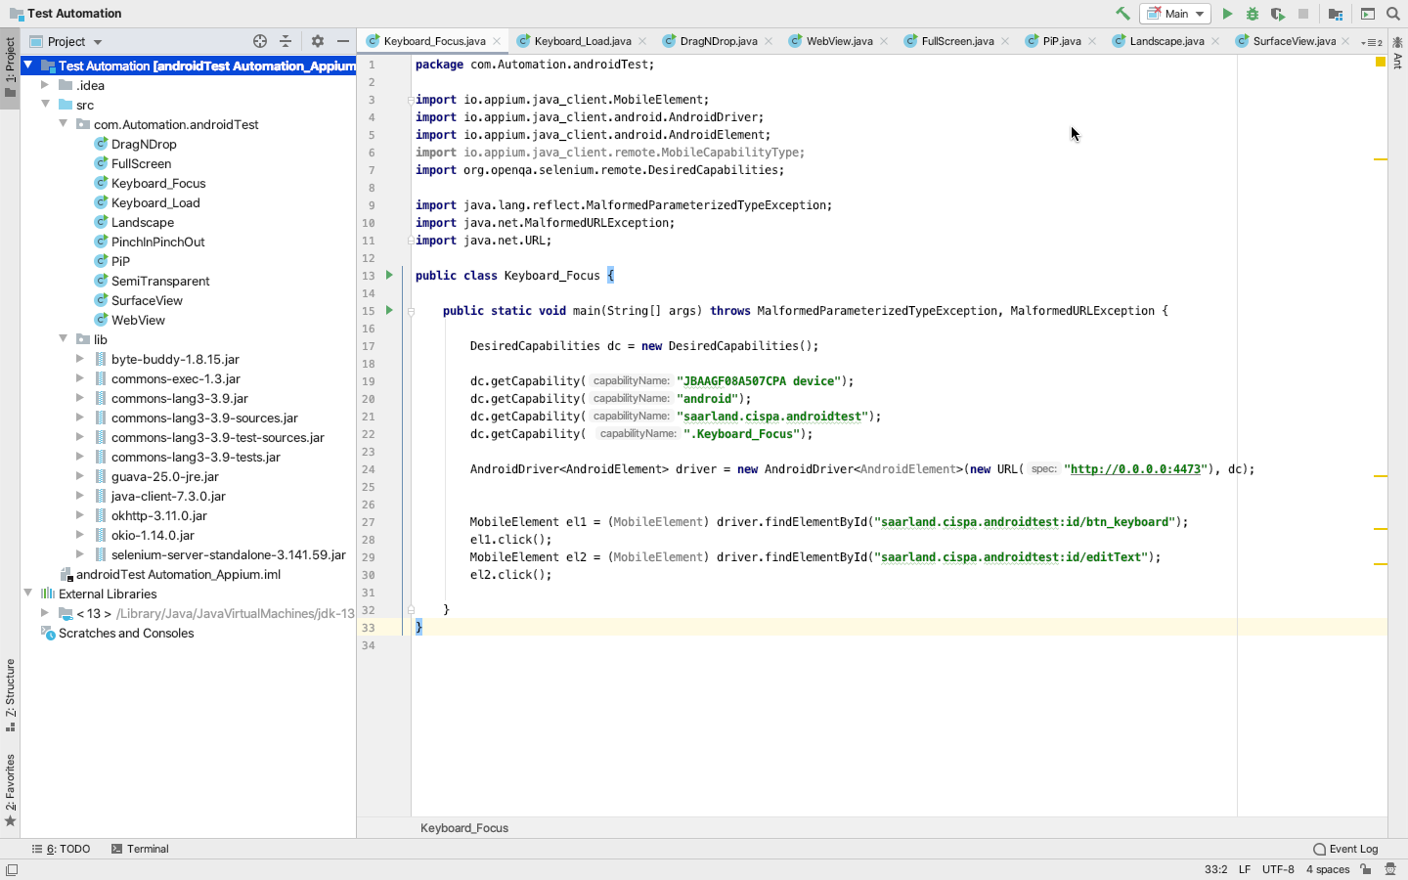

Appium starts with a server that is operated at the local port

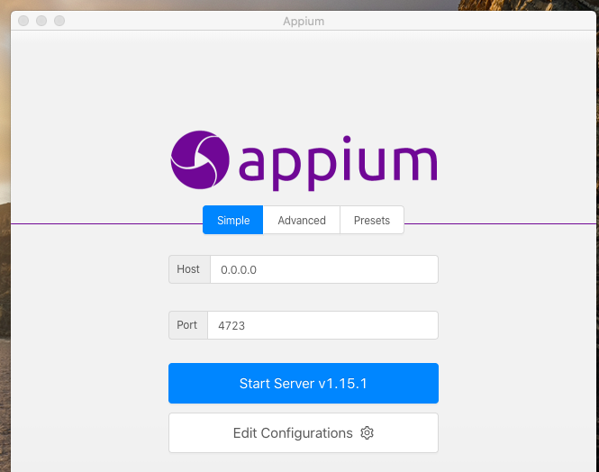

Once we start the server, it displays the interface listener

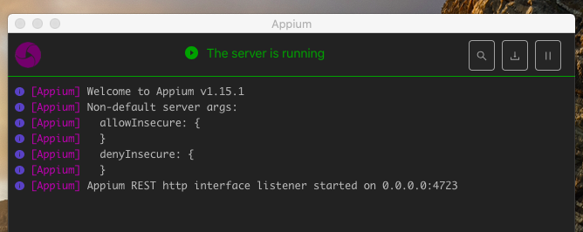

We can open the inspector session declare the Attribute settings like desired capabilities like port number, emulator/device name and package name of the applications to be tested. The code automatically represents in JSON.

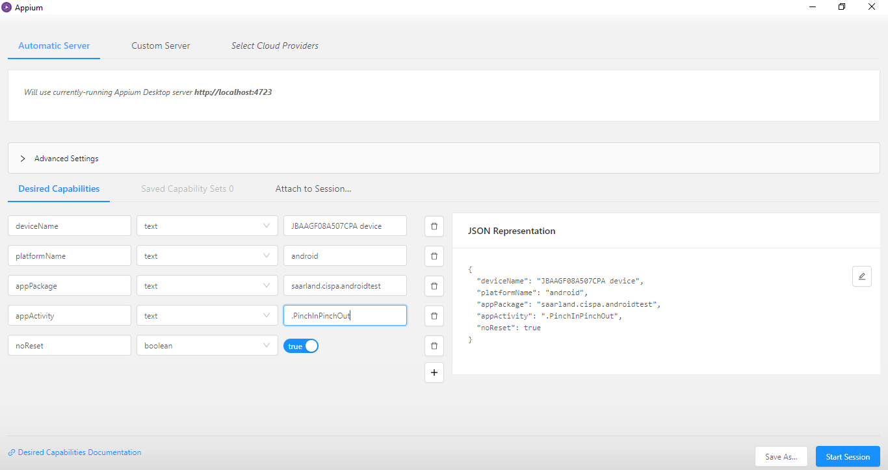

After the declaration of desired capabilities accordingly, the application is automatically launched either from device or from the emulator.

Then, the code to invoke the test activities of a particular application is written as a test script on intellij IDE.

The **URL** of the Appium server must be declared in **AndroidDriver**



The Appium Server then displays the “screenshot” of the device or emulator where the application runs automatically. But we need to click the **refresh** button to view the current state of the application.

We have tested all the all the applications created so far and **automation script**(in JAVA) for each application could be founded in the following folder:

**Automation Test Suite 🡪 Test Automation 🡪 src 🡪 com 🡪 Automation 🡪 androidTest**